**Project Design Phase-II**

**Data Flow**

|  |  |
| --- | --- |
| Date | 28 October 2022 |
| Team ID | PNT2022TMID09823 |
| Project Name | Signs with Smart Connectivity for  Better Road Safety |
| Maximum Marks | 4 Marks |

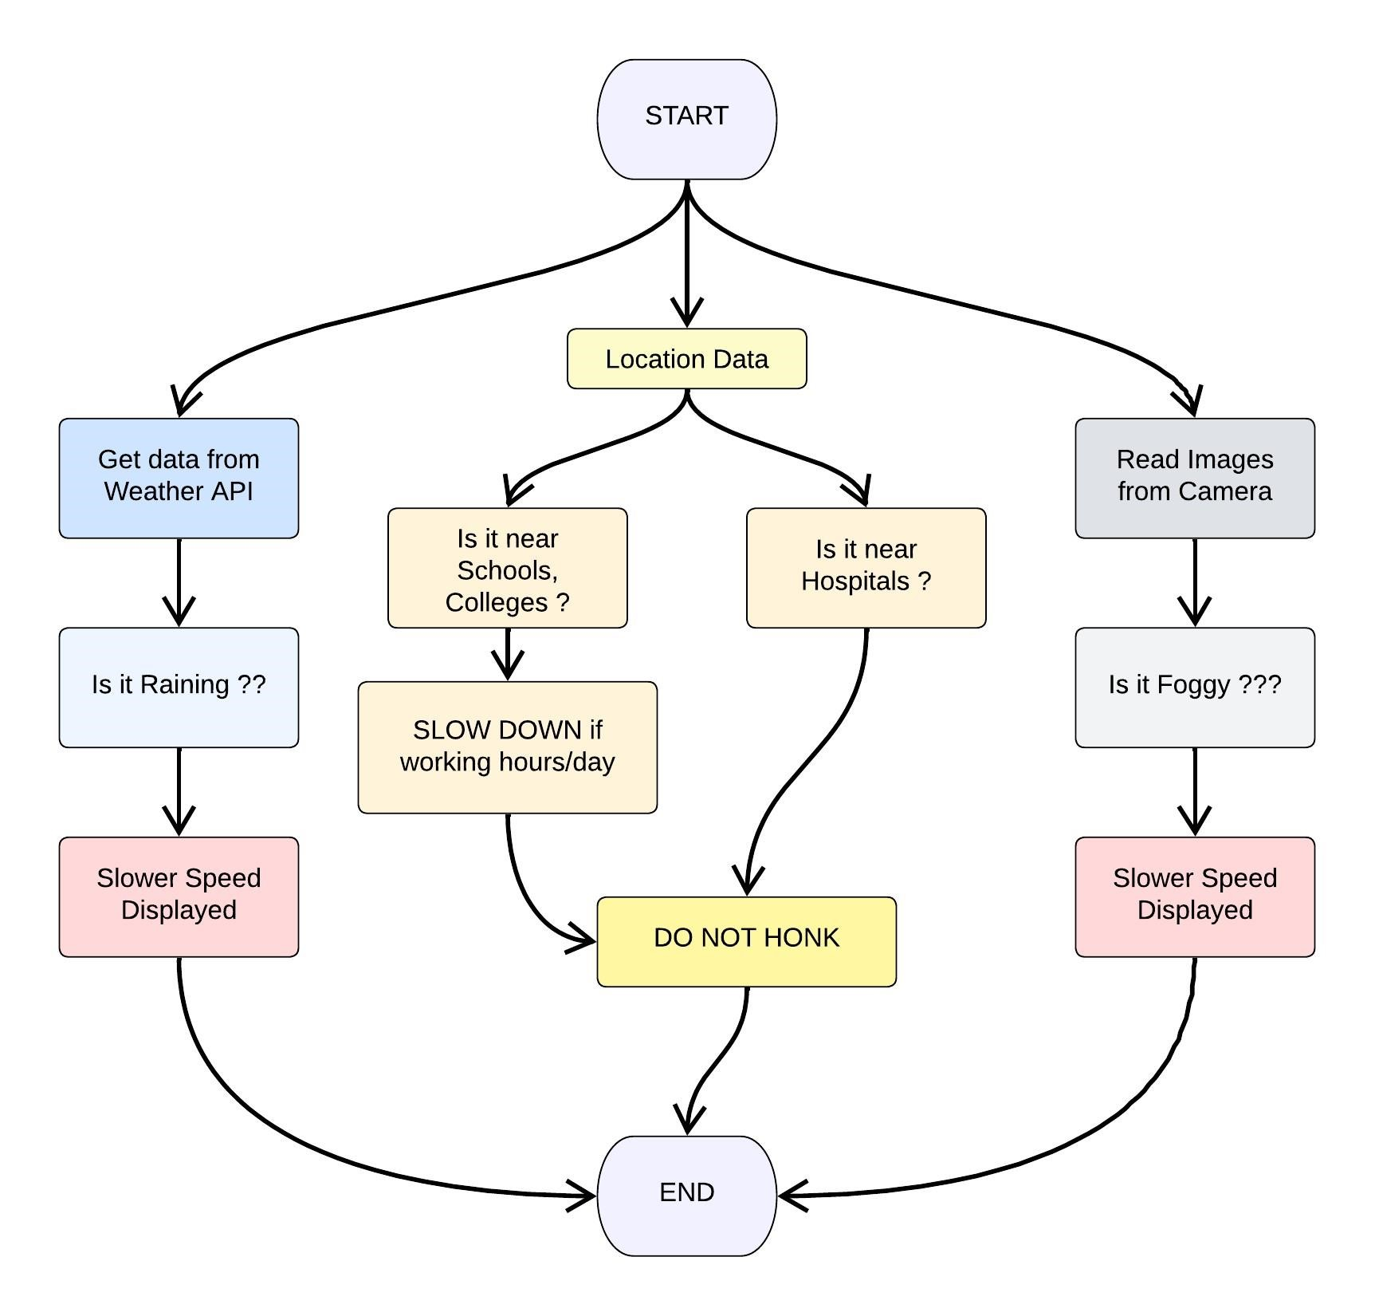

1/1